# CS 340 AnimalShelter+ README

## About the Project/Project Title

**AnimalShelter+** is a Python module that implements CRUD (Create, Read, Update, and Delete) functionality. It is designed to interface with a MongoDB database that contains data for Animal Center outcomes.

## Motivation

The motivation for **AnimalShelter+** is to provide a secure and stable interface for a client application to interact with the animal shelter database. By handling database operations within this module, the main application doesn't need to contain sensitive credentials, and the database logic is kept separate and reusable.

## Getting Started

In order to get started with the project, Install the required dependencies listed below Installation section and follow the code examples to get started. Feel free to contact one of the authors if you need additional assistance.

## Installation

* Python 3: The core programming language used to develop the CRUD module.
* MongoDB: The NoSQL document database used to store the animal shelter dataset. Its flexible schema is well-suited for this type of data.
* PyMongo: The official Python driver library for MongoDB. It's the standard tool for enabling communication between a Python application and a MongoDB database.
* Jupyter Notebook: An interactive development environment used to test the Python module's functionality in a clear, cell-by-cell format.
* Ubuntu: The Linux-based operating system where the database was hosted and the code was developed.

***IMPORTANT NOTES***

It is important to update the following variables based on your own credentials:

* USER: Your assigned username
* PASS: Your assigned password
* PORT: The available host port available to you

## Usage

CRUD is a set of operations that stands for Create, Read, Update, and Delete, which are the four fundamental operations for managing data in a database which are used to persistently store and manage information:

* Create: This is the operation to add new data.
* Read: This operation retrieves or searches for data.
* Update: This operation modifies existing data.
* Delete: This operation removes existing data.

### Code Example

1. Start by importing the AnimalShelter class and initializing an object of AnimalShelter()
   1. *# Import the class from .py*
   2. *from AnimalShelter import AnimalShelter*
   3. *shelter = AnimalShelter()*
2. Create a sample data that can be inserted into the database
   1. *# Data for a new animal document*
   2. *dog = {*
   3. *"animal_id": "TEST100",*
   4. *"animal_type": "dog",*
   5. *"breed": "Test Breed",*
   6. *"color": "Black"*
   7. *}*
3. Call the *.create()* method to add a new animal document
4. Call the *.read()* method to query for that animal document
5. Call the .update() method to update an existing document
   1. The update method requires two parameters:
      1. Animal ID of an existing record
      2. The key and values of the fields to be updated
6. Call the .delete() method to delete an existing document

### Dashboard

The dashboard is an interactive web application that allows the user to identify and categorize potential search-and-rescue dogs by visualizing and filtering data from the Austin Animal Center database.

*Key Capabilities*

* Interactive Filtering: User is able to filter for specific rescue types.
* Dynamic Chart: Users are able to interact with a visual pie chart that is generated based on the selected rescue categories
* Interactive Map: An interactive map below the data table shows the current location of each individual rescue animal

### Tests

*The AnimalShelter pyhon class is setup with debugging capabilities. Failures in any method in the class should return a descriptive error message.*

### Screenshots

Import Austin Animal Center Outcomes data set

User creation and authentication

Sample create and read requests

Sample update document request

Sample delete document request

Dashboard filter screenshots

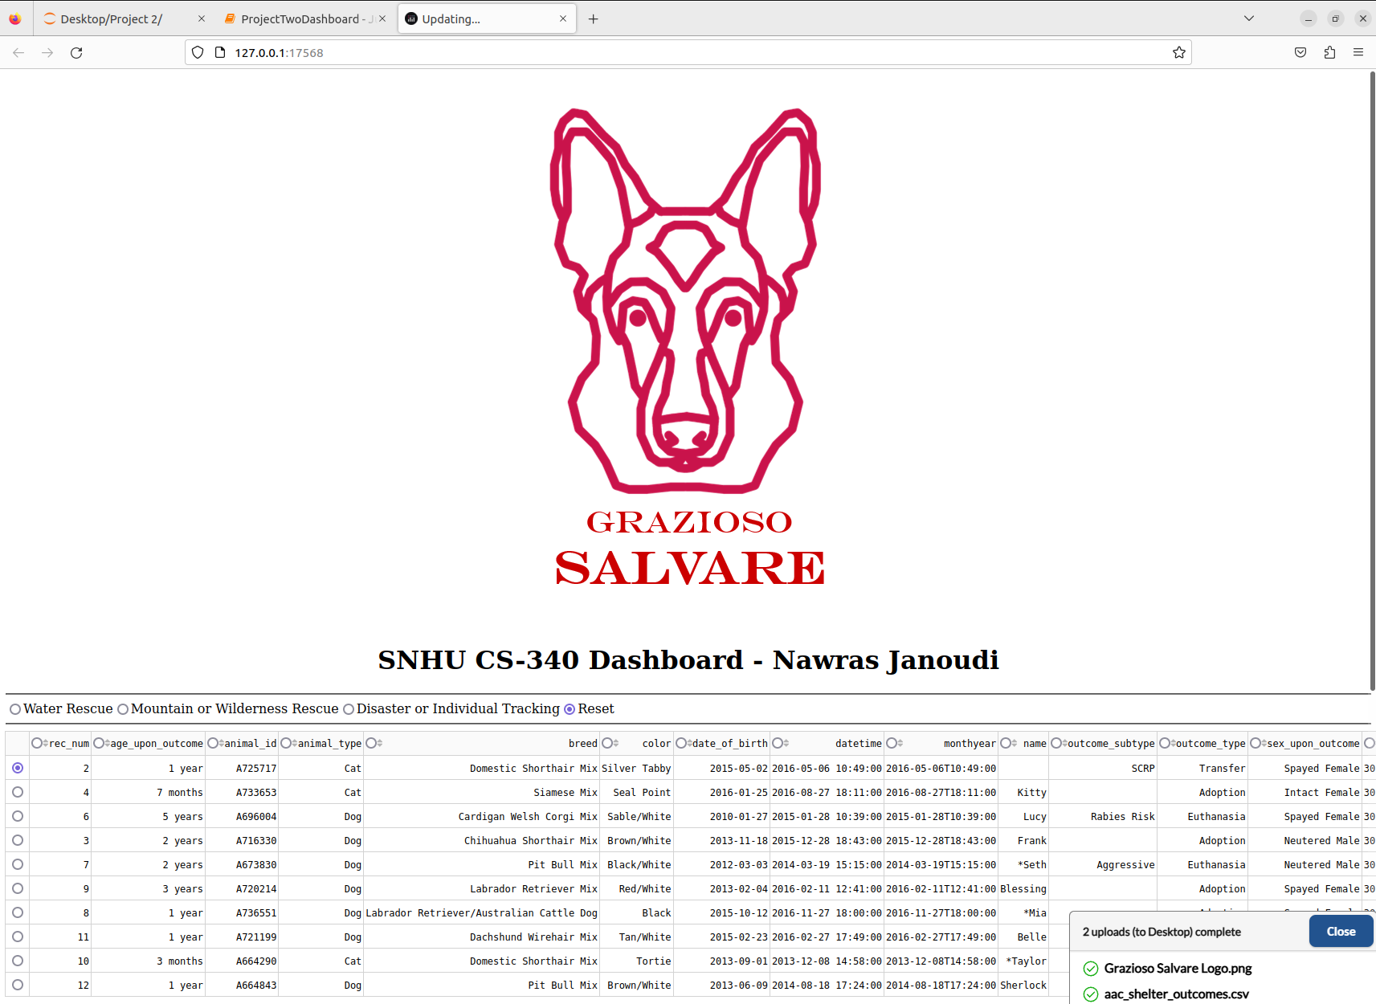

## Roadmap/Features

Future releases will improve features such visual representation of different animal data such as outcomes and results

## Contact

Author: Nawras Janoudi